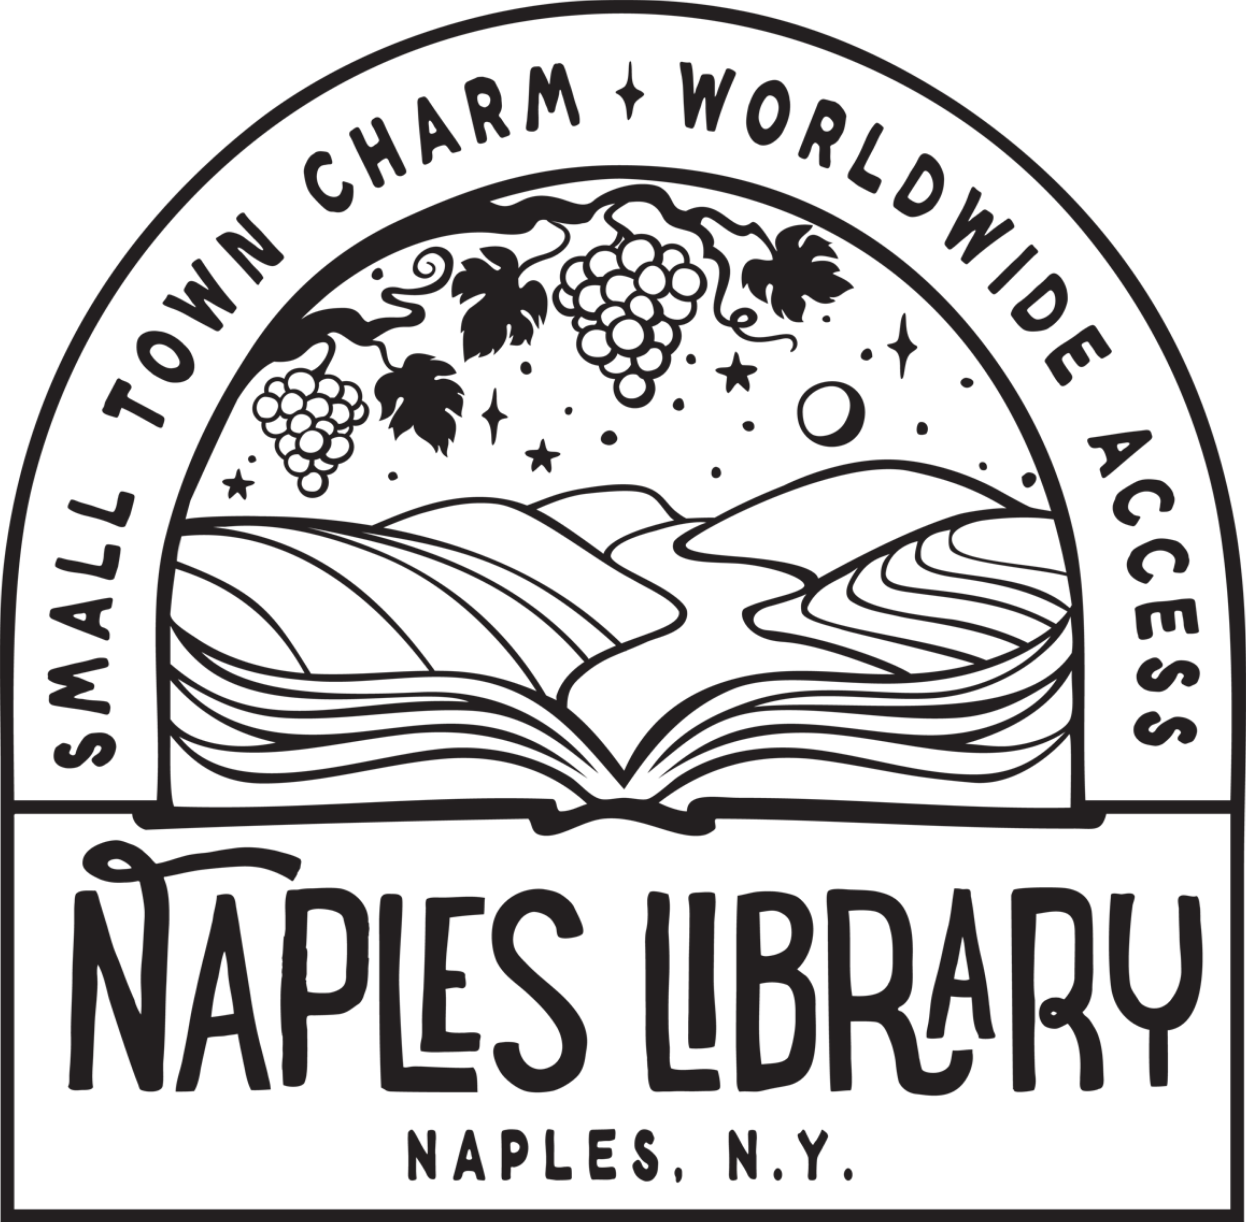

Press Release
For Immediate Release
Contact: Kendyl Litwiller-Sutherby
Naples Library
(585) 374-2757
napleslibrarydirector@owwl.org

NAPLES LIBRARY EXPANSION PROJECT INCREASES ACCESSIBILITY FOR ALL

EVENTS:

Community Q&A Event
Thursday, September 29th at 6:00p.m. in the Naples Library, 118 S. Main Street, Naples, NY, in the meeting room (lower level).

Groundbreaking Celebration
To be held at the library’s back door on Harwood Lane, Naples, NY.
Check the library’s website and social media for date TBD in mid-October.

NAPLES, NY (September 2022) The Naples Library Board of Trustees and staff are proud to announce that construction is set to begin on the Naples Library Accessibility and Expansion Project this fall. Thanks in part to substantial funding from a State Aid for Library Construction Grant, this $1.3 million project will transform our community library into a space with increased accessibility for all patrons and visitors, and will also include much needed upgrades.
Kendyl Litwiller-Sutherby, Naples Library Director, said, "We are very excited to be able to make our building more accessible to our community members. The inclusion of an elevator will make a big difference for a lot of people and we are really proud to be able to make changes to our building without putting the burden on our tax payers, which was made possible due to the State Aid for Library Construction Grant."
Ron Kirsop, Executive Director, OWWL Library System said,"We greatly appreciate New York Library Association, Assemblyman Jeff Gallahan, Senator Samra Brouk, and all the library supporters who advocate for State Aid for Library Construction each year, helping to fund projects like the Naples Library expansion and renovation project. The Town of Naples is an incredible place, and it is fantastic to see the library growing alongside its community."
“The Accessibility and Expansion Project at the Naples Library is certain to enhance access to this valuable community resource. Those currently using the Naples Library are likely to benefit from a seamless flow to all resources available within,” said Brian Schenk, Naples Village Mayor, “The completion of this project will undoubtedly attract persons with mobility issues as accessibility is at the core of the effort. Expansion to enhance current resources and provide accessibility is well recognized as a necessity to maintain and increase public utilization.”

Community Q&A Event
Thursday, September 29th at 6:00p.m. in the Naples Library, 118 S. Main Street, Naples, NY, in the meeting room (lower level).
During this event, Library Director Kendyl Litwiller-Sutherby and library trustees will be available to answer questions about this expansion project, with floor plans and renderings of the library’s new facilities also on view. All are welcome to attend.

Groundbreaking Event
To be held at the library’s back door on Harwood Lane, Naples, NY.
Check the library’s website and social media for date TBD in mid-October.
Parking for the event is limited and those attending are asked to park at the municipal parking lot (behind the Morgan Hose Building on Mill Street) and not at adjacent businesses.

Why We Need an Expansion
Full use of the Naples Library has always been compromised by a lack of accessibility between the upstairs and downstairs levels. When inside the library, people with limited mobility can only access the downstairs by going outside and re-entering from Harwood Lane (the road which runs behind the library, parallel to Main Street). The Accessibility and Expansion Project is a solution to this problem.
To manifest this project, we sought out HBT Architects of Rochester, NY, who have created a plan for us to increase the accessibility of the library while adding some much needed upgrades in support of our vision, to "inform, inspire, educate and entertain area residents of all ages, in an easily accessed, resource rich environment."

Features of the new space
The new facilities will have plenty of exciting features and a focus on inclusive elements so that all members of the area served by the Naples Library can enjoy the space.
The scope of work for this project is a 1,053 square foot addition consisting of a new elevator, entry lobby, and vestibule for increased accessibility and physical connection between the two levels. A new entry with a second circulation desk will be added at the lower level to support secondary patron access at Harwood Lane. A curb and small entry garden will be constructed along with the back entry, and two accessible parking spaces will be added to the parking area behind the library on Harwood Lane.

What will change?
- Elevator
- Teen Room
- Updated Meeting Rooms
- Updated Archive Climate Control
- ADA Parking
- New Lower Level Entry Lobby
A Teen Room will be added in the new part of the first level. Celia, a teen library patron, pointed out that a designated teen space will offer a way to find community beyond school: “People you might want to be friends with might not be in your classes, but you could hang out after school at the library since there'll be a space just for that.”
Updated Meeting Rooms and a Lower Level Entry will provide more opportunities for use by community organizations, by enabling scheduled public access.
The library’s dedicated local history space and archives in the lower level will also be enhanced, with an updated climate control system for preserving important documents and collections donated by Neapolitans that tell the stories of Naples history.
“Quite a few senior citizens use the downstairs for meetings and programs and I know that they would be excited to see an elevator installed in the library,” said Blanche Warner, Former Naples Library Director and current Library Archive Volunteer.
"The new elevator will provide equitable library services to patrons with short and term disabilities and low mobility and those using wheelchairs and other assistive devices, including Seniors and Older Adults who are active library users but may find the stairs between levels difficult to navigate. The Naples Library project will ensure that all community members can fully access the library's materials, programs, and facilities," said Suzanne Macaulay, Program Director, OWWL Library System.

What will stay the same?
- Main circulation desk
- The library’s Main Street façade
- Periodicals Room
- Location of Adult Books
- Computer area
- Children’s Room
- Our friendly and helpful staff
Much of the main floor will remain the same, including the stacks and the adult book collection. The Children’s Room will remain the same, with the benefit that most of the children’s book collection will be relocated closer to it on the lower level.
Disruptions to library programming are expected to be minimal. The dates of any closures will be posted at the library and on the library’s website and social media accounts (Facebook and Instagram) in advance.
There will be no changes to the library’s Main Street façade. All neighboring businesses will be informed in advance about potential noise or parking impacts. Barring unforeseen circumstances, the new construction is expected to be completed by mid-year 2023.

Project Funding
To supplement the funding of this project, Naples Library has applied for State Aid for Library Construction, a grant award through the New York State Division of Library Development and administered locally by OWWL. Money awarded through this program allows individual libraries to improve access to their facilities. In a very competitive grant cycle, the Naples Library expects to receive approximately $500,000 towards the $1.3 million project.
Naples Library will also use its investment fund to complete this expansion project, which means it will not be funded by the local tax levy or our regular operating budget. We are also seeking additional funds through community gifts to help towards unanticipated costs.
- State Aid for Library Construction Grant: $522,325
- FLACE - Library Endowment: $854,409
- Friends of Naples Library: $6,000
- Local Tax Levy: $0

How You Can Help
All funds raised for this project will be handled through the “Friends of the Naples Library”, our non-profit fundraising group. Their upcoming fundraising campaign will include an offering of naming opportunities for donors. If you would like to make a contribution, please reach out to Vice President of the Friends of the Naples Library, Michelle Wernsing at mwconsulting55@gmail.com for more information.
Donations via check should be made payable to Friends of Naples Library and mailed to Naples Library, P.O. Box 157, Naples NY 14512.
Please contact the library at 585-374-2757 to find out more about joining the Friends of the Naples Library or to inquire about other volunteer opportunities. Fundraising events in the past have included community book sales, silent auctions and raffles.

Naples Library is part of the OWWL Library System, a New York State chartered, cooperative public library system serving the forty-two public libraries in Ontario, Wyoming, Wayne and Livingston counties. OWWL offers centralized cataloging and delivery of member library materials through the OWWL catalog.
The Naples Library is also planning a grand opening celebration upon completion of the project.

